Project: Static Website Hosting on S3

Overview
To configure an Amazon S3 bucket to serve static web content directly to the public internet, bypassing the need for a traditional web server (like Apache or Nginx). 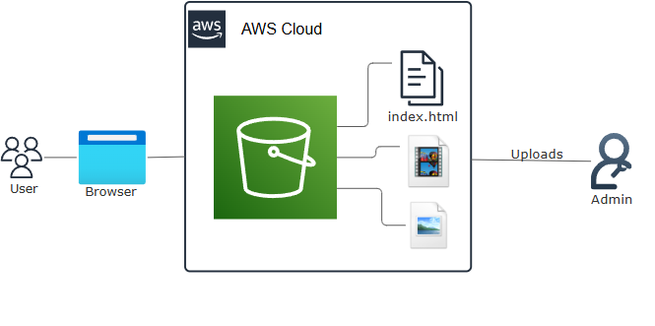

Skills and Concepts Demonstrated
- Cloud Storage & Hosting: Utilizing Amazon S3 for durable and highly available static content delivery.
- Access Control: Implementing public read policies using S3 Bucket policies (JSON).
- Networking: Identifying and utilizing the S3 Bucket Website Endpoint URL.
- Operational Discipline: Applying resource tags for organization and cost allocation.

Step-by-Step Guide

1. Create and Configure the S3 Bucket
- Navigate to the S3 Console and click Create bucket.
- Name the Bucket: Choose a globally unique name (e.g., static-hosting-ish).
- Public Access: Scroll down to "Block All Public Access" and UNCHECK the box to allow public access and also click on the new acknowledgement checkbox.
- Add Tags: Add any tags you want to help with organisation (e.g., Project: Static Hosting)
- Click Create bucket.

2. Enable Static Website Hosting
- Select the new bucket and go to the Properties tab.
- Scroll to the bottom and click Edit next to "Static website hosting."
- Select the Enable radio button.
- Index Document: Set this to index.html.
- Click Save changes.

3. Upload Application Files
- Go to the Objects tab.
- Click Upload and upload your index.html file.

4. Configure Public Read Access (Bucket Policy)
This step grants anonymous users the ability to download files (s3:GetObject) from the bucket.
- Go to the Permissions tab.
- Under "Bucket policy," click Edit.
- Paste the following JSON code, replacing YOUR-BUCKET-NAME-HERE with your bucket's name:
{
"Version": "2012-10-17",
"Statement": [
{
"Sid": "Allow Access",
"Effect": "Allow",
"Principal": "*",
"Action": "s3:GetObject",
"Resource": "arn:aws:s3:::YOUR-BUCKET-NAME-HERE/*"
}
]
}
- Click Save changes.

5. Verification
- Return to the Properties tab.
- Scroll down to Bucket website endpoint and copy the URL.
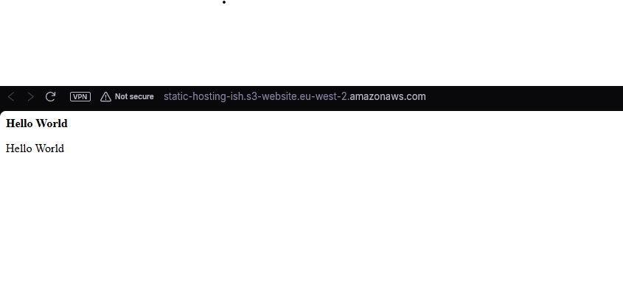
- Open the URL in a browser to confirm the website loads successfully.

